**Learning Activity 4-04**

**Is about:**

* Perform SELECT queries on a single table with simple selection conditions.
* The entire activity will be worked with tables from the world database.

**Goals:**

* Edit and execute SELECT statements on a table according to the required requirements.
* Use the WHERE clause within the SELECT statement.
* Use the logical operators OR, AND and NOT in selection conditions.
* Select to filter with null or non-null values in one or more columns.
* Use the BETWEEN, IN and LIKE clauses in selection conditions.

**Exercises**

1.- Obtain unofficial languages that are spoken in countries by more than 40% of their population. Also show the percentage and the country code in which they are spoken.

2.- Obtain without repeating unofficial languages spoken in countries by a percentage between 5% and 10% of their population. The list must be ordered alphabetically by language.

3.- Obtain names, population and continent of countries belonging to Asia, Africa or Europe that have a population greater than 50 million inhabitants. Sort by population from largest to smallest.

4.- Obtain the names, population, and continent of the five most populated countries in Africa or Asia with populations between 10 and 50 million inhabitants.

5.- Obtain the names and continent of all the countries in Asia that do not have a recorded year of independence.

6.- Obtain the name and country code to which all the cities whose name begins with S belong, ordered by country code and then by name.

7.- Obtain the name, population, region, and form of Government of all the countries in Asia except those that do not have a registered year of independence or GNPold.

8.- Obtain the name, population, continent of all countries that do not belong to Europe and whose name begins with N or S and with more than two million inhabitants.

9.- Obtain all the countries with a population density between 50 and 60 inhabitants per km 2 ordered by name. The population density is obtained by dividing the population by the area.

10.- Obtain the name of all the countries that have become independent in the 20th century along with their year of independence.

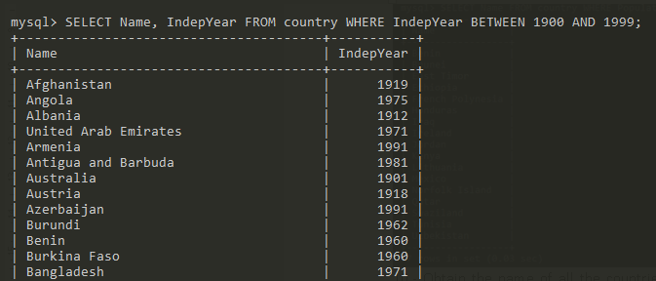

11.- Obtain the name, continent, and year of independence of the five countries that are oldest according to their year of independence. **Territories that have never become independent should not leave.**

12.- Obtain the names of all the countries whose name begins and ends with the letter A and contains the letter E.

